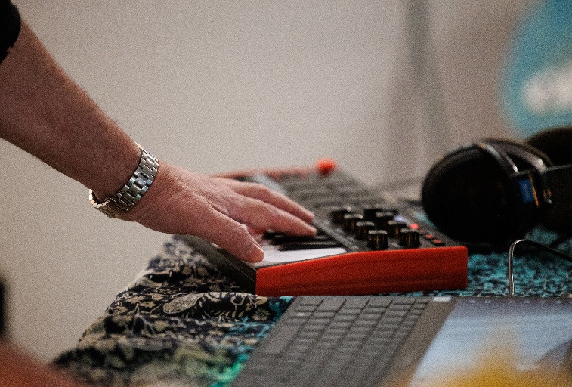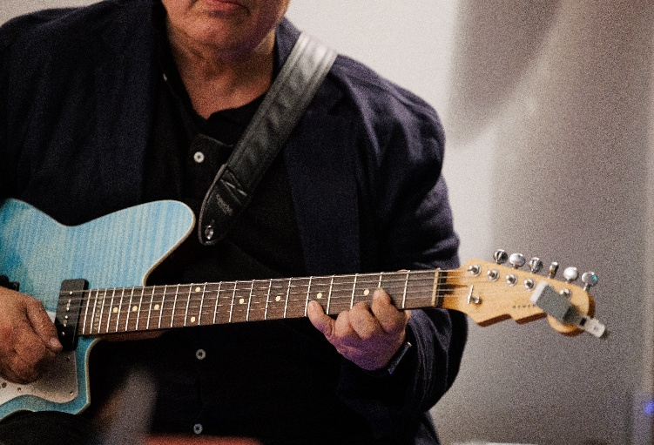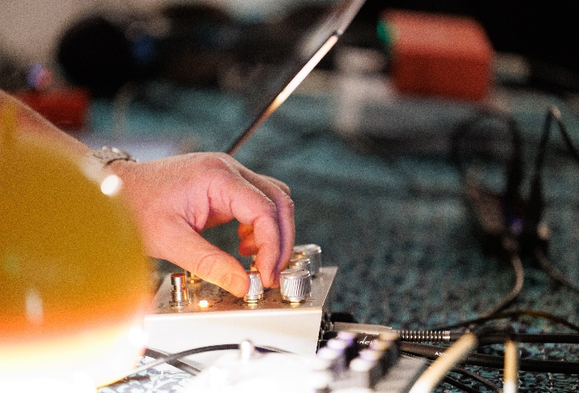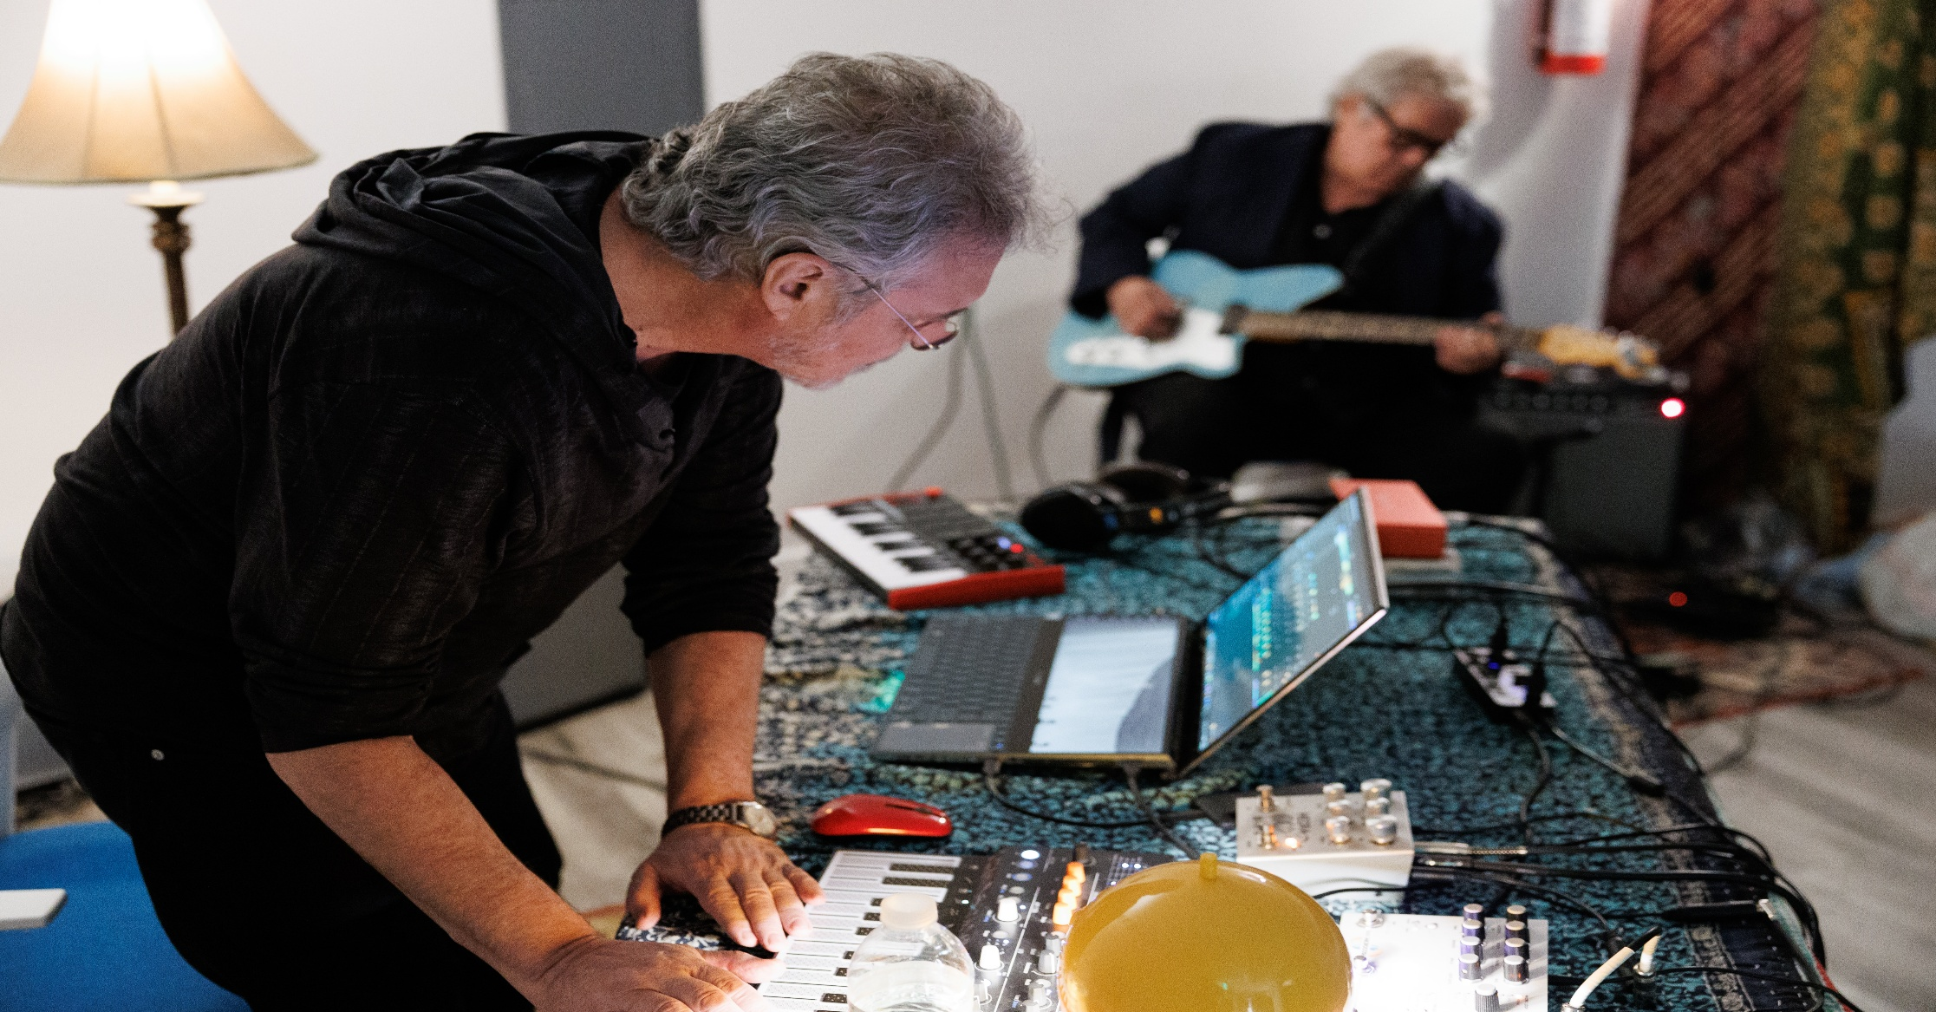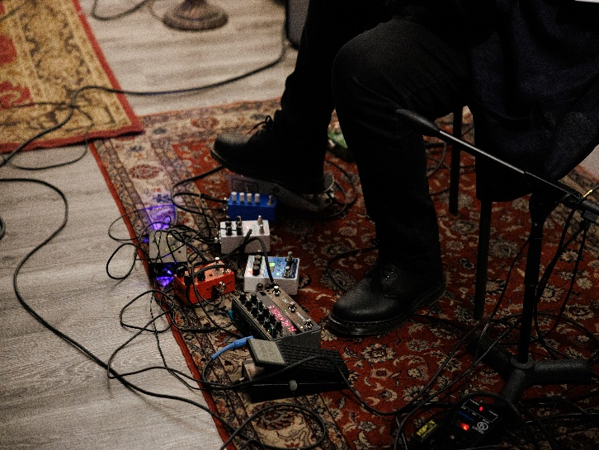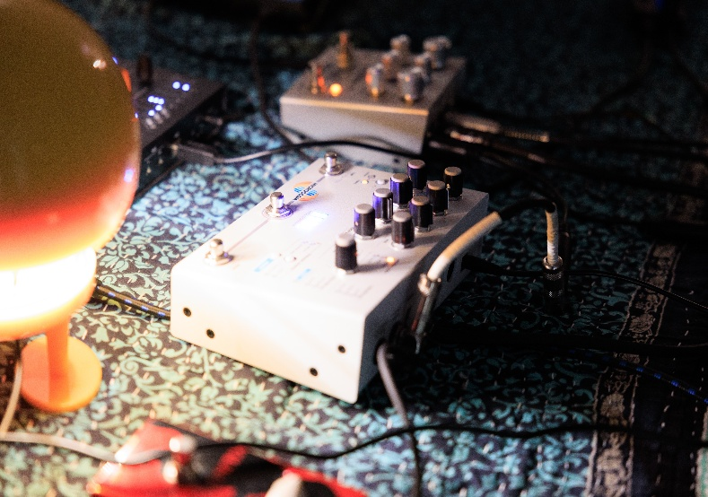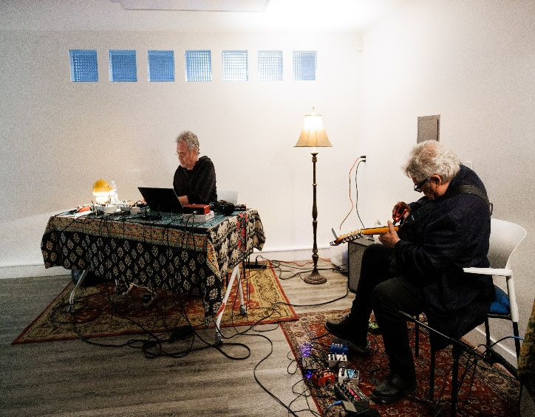

NOTNEF GRECO – LIVE @ CAL ARTS

Sadly, this album might turn out to be a trace from a bygone era. On January 24, 2025, just four days after Trump’s official takeover began to wage catastrophe on American society and the world, Notnef Greco played a short live set at a garage space in downtown LA at the invitation of the California Institute of the Arts and in the context of an event titled *Experiments in Listening*.

The event was shrouded by the apocalyptic firestorms that were still burning in various parts of the city and the death of David Lynch just a few days before. The performance, which demanded nimble maneuvering of dire circumstances for the two musicians, was conceived as a tribute to Lynch’s inspiration and to LA itself, as the city that spawned their long-term friendship over decades of different lives lived in its embraces. By all accounts it was a strange gesture of healing, of people just being present, coming together as the world was going to hell, of reuniting with friends and retracing old steps in various parts of the city.

As free and fun as the performance was, various tech mishaps marred the recording. The live digital recordings of “Somewhere there’s a bomb for you,” “Move over,” and “Under the wire” are pretty much intact. The improvised poem “Time we deliver” was reconstructed by piecing together two cell phone recordings, with lo-fi issues still evident despite the studio cleanup. “She beat them all” and “Message from Pena” were reconstructed from recorded fragments and added improvisations as the musicians returned to their home studios in Berkeley and New York. But the overall composition and sequence of the pieces renders precisely what took place that evening.

This would have never happened without the gracious hospitality of Arne de Boever, Kara Keeling, and Erin Graff Zivin and particularly Arne’s gentle but stubborn prodding that the performance take place against all odds. Profound thanks are also extended to Michael Pisaro-Liu for his advice and his guitar amp; Angel Origgi for his evocative photography featured on the cover; and Karena Essex for her meticulous video documentation but above all her sheer presence.

CREDITS

Deviant Fond: guitars, effects, keyboards (3)  
Count G: synths, electronics, voice (2)

David Lynch reads “Pena” by Don Van Vliet (5)  
  
All compositions, arrangements, mixing by Notnef Greco  
Recorded live in Los Angeles, January 24, 2025  
Additional improvisations recorded at Sinking Ship Studios, Berkeley CA and The Boys Room, NYC  
Mastered at Terra Infirma  
  
Cover design by Todd Brunner  
Photographs used by permission of Angel Origgi  
  
Courtesy of Sublamental Records